**Chapter 8 - The Eagle**

**All Lectures Uploaded on YouTube:** [**https://tinyurl.com/fkm9-english**](https://tinyurl.com/fkm9-english)

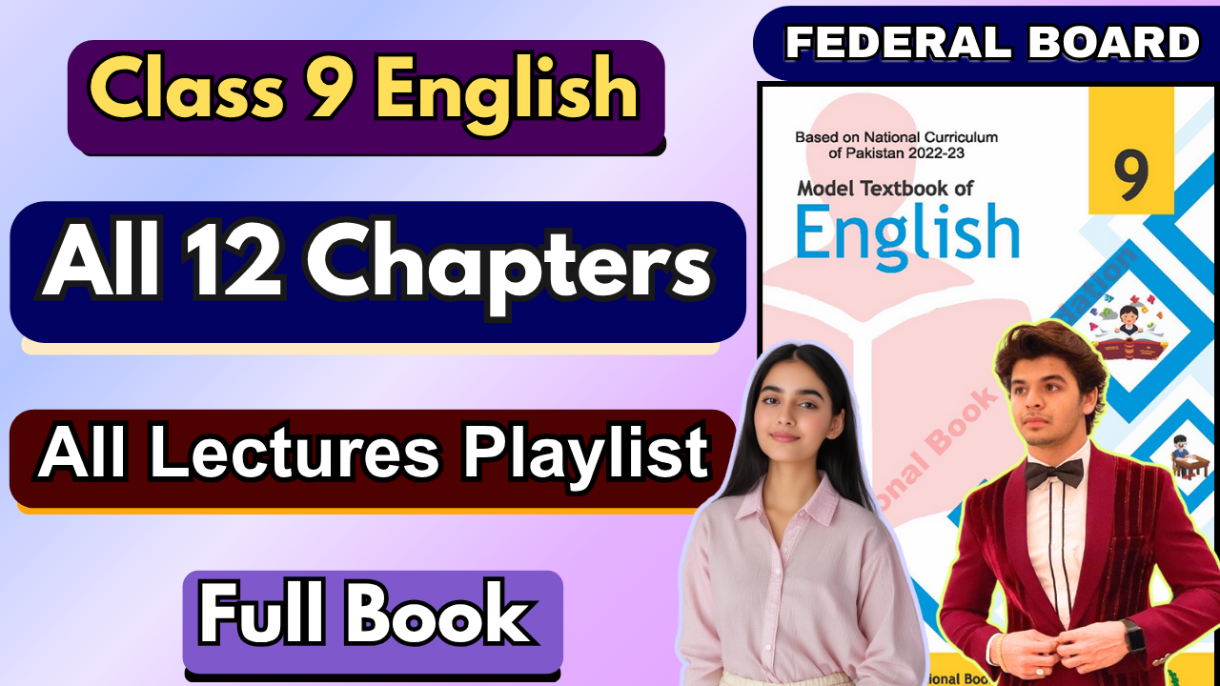

**Glossary:**

**Given below are the difficult words from the unit. Look at their meanings and use these words in your own sentences.**

| **Words** | **Meaning** |
| --- | --- |
| clasp | to hold someone or something firmly in your hands or arms |
| crag | a high, rough mass of rock that sticks out from the ground around it |
| crooked | not forming a straight line, or having many bends |
| azure | having the bright blue colour |
| wrinkled | having small lines |
| thunderbolt | a flash of lightning and the sound of thunder together |



The following are the sentences for the above mentioned words:

1. **Clasp** – She tried to **clasp** her mother’s hand tightly as they crossed the busy street.
2. **Crag** – The mountain climber stood on a narrow **crag**, gazing at the valley below.
3. **Crooked** – The old man walked down the **crooked** path that twisted through the forest.
4. **Azure** – The sky was a clear **azure** blue, stretching endlessly over the calm sea.
5. **Wrinkled** – Her **wrinkled** hands told stories of years filled with hard work and love.
6. **Thunderbolt** – A sudden **thunderbolt** lit up the dark sky, followed by a deafening roar.

**Reading and Critical Thinking Skills**

**A. Reading Comprehension Questions:**

1. **Who or what is the main subject of the poem?**

**Ans.** The main subject of the poem is the eagle, depicted as a majestic and powerful bird.



# What is the significance of the subject's physical attributes, such as "crooked hands" and being "close to the sun"?

**Ans.** The phrase "crooked hands" metaphorically describes the eagle's sharp, curved talons, which reflect its strength and ability to grasp firmly. Being "close to the sun" symbolizes the eagle's superiority, isolation, and dominance in nature.

# How does the poem explore the theme of solitude or loneliness?

**Ans.** The eagle is depicted as solitary, perched "in lonely lands" high above the world. This emphasizes its isolation in nature, highlighting both its independence and a sense of loneliness.

# What is the overall tone of the poem, and how does it change throughout the stanzas?

**Ans.** The tone of the poem is initially majestic and awe-inspiring, as the eagle is portrayed as dominant and powerful. In the second stanza, the tone shifts to dramatic and dynamic with the eagle's sudden dive "like a thunderbolt."

# Which figure of speech is used in "He clasps the crag with crooked hands," and comment on its effect?

**Ans.** The figure of speech is **personification**, as the eagle’s talons are described as "crooked hands," giving it human-like qualities. This emphasizes the eagle’s grip and strength while creating a vivid and relatable image

.

# How does the final line, "like a thunderbolt he falls," relate to the preceding lines and the poem's central theme?

**Ans.** The final line conveys the eagle’s sudden and powerful descent, reflecting its dominance and force. This line contrasts with the earlier calm and stillness, underscoring the central theme of nature’s strength and the eagle's majestic control over its surroundings.

# Grammar

# Complex Sentences

**Definition:**

A complex sentence consists of one independent clause and at least one dependent clause. It works best when additional information is provided to explain or modify the main sentence’s point.

* + - Uses subordinating conjunctions like *because, since, or until* to connect clauses.
    - Dependent clauses (subordinate clauses) **cannot stand alone** as a sentence; they depend on the independent clause for meaning.

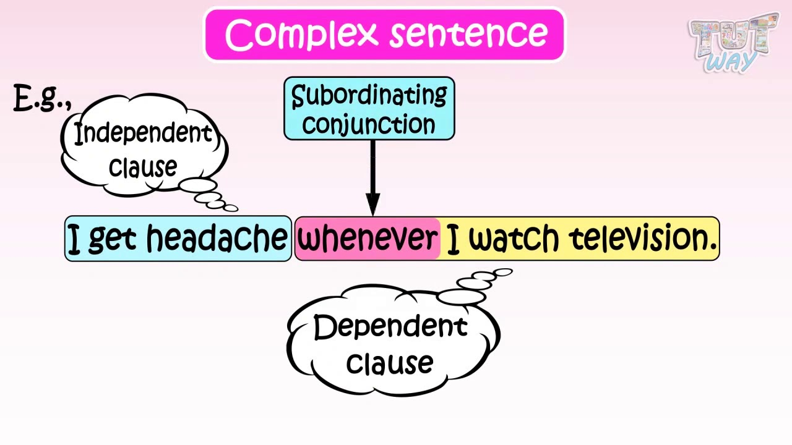

# Structure

1. **Independent Clause:**

A sentence that expresses a complete thought and can stand alone.

* + Example: *You cannot leave the school.*

# Dependent Clause (Subordinate Clause):

A group of words with a subject and verb but not a complete thought; cannot stand alone.

* + Example: *Until the bell rings.*

# Examples of Complex Sentences

* *When I grow up, I will use complete sentences.*
  + Independent Clause: *I will use complete sentences.*
  + Dependent Clause: *When I grow up.*
* **Conditional Sentences:** Often used to discuss hypothetical situations, often with an "if-then" structure.
  + Example: *If you’re always trying to be normal, you will never know how amazing you can be.*

# Subordinating Conjunctions

**Commonly used subordinating conjunctions include:**

* Cause/Effect: *Because, since, as*
* Time: *When, after, before, while, until*
* Contrast: *Although, even though, though*
* Condition: *If, unless, provided that*

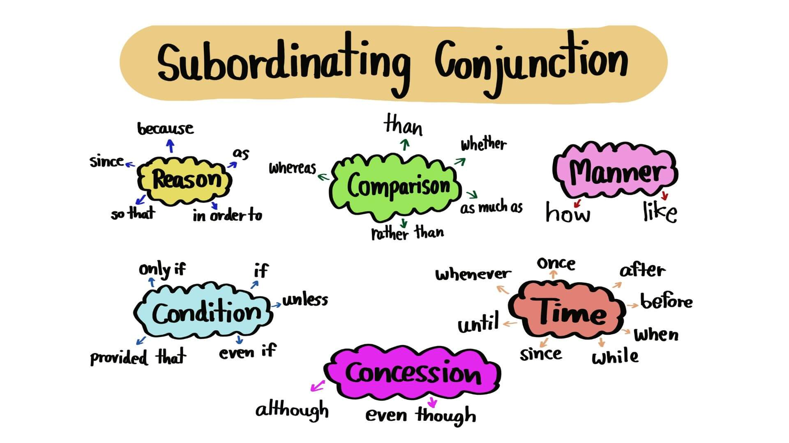

# Exercise: Construct complex sentences using main and subordinate clauses with appropriate transitional devices and correct punctuation.

**1. Main Clause:** I enjoy hiking in the mountains.  
**Subordinating Clause:** Because it helps me relax after a busy week.   
**Complex Sentence:** I enjoy hiking in the mountains because it helps me relax after a busy week.

**2. Main Clause:** She baked a delicious cake.  
**Subordinating Clause:** After she found a new recipe online.  
**Complex Sentence:** She baked a delicious cake after she found a new recipe online.

**3. Main Clause:** Since my favorite band was performing.  
**Subordinating Clause:** I decided to attend the concert.  
**Complex Sentence:** Since my favorite band was performing, I decided to attend the concert.

**4. Main Clause:** He decided to learn a new language.  
**Subordinating Clause:** So that he could communicate with international clients.  
**Complex Sentence:** He decided to learn a new language so that he could communicate with international clients.

**5. Main Clause:** We waited patiently for the rain to stop,

**Subordinating Clause:** while we sought shelter under the old oak tree.

**Complex Sentence:** We waited patiently for the rain to stop while we sought shelter under the old oak tree.

**6. Main Clause:** My cat loves to play with a ball of yarn,

**Subordinating Clause:** although she often gets it tangled around the furniture.

**Complex Sentence:** My cat loves to play with a ball of yarn, although she often gets it tangled around the furniture.

**7 .Main Clause:** We had to cancel the meeting,

**Subordinating Clause:** because she had a prior commitment.

**Complex Sentence:** We had to cancel the meeting because she had a prior commitment.

**8. Main Clause:** The movie was scary,

**Subordinating Clause:** even though it was meant for children.

**Complex Sentence:** The movie was scary even though it was meant for children.

**9. Main Clause:** We planned a picnic in the park,

**Subordinating Clause:** since the weather forecast predicted a clear, sunny day.

**Complex Sentence:** We planned a picnic in the park since the weather forecast predicted a clear, sunny day.

**10. Main Clause:** We decided to adopt a puppy,

**Subordinating Clause:** after visiting the animal shelter.

**Complex Sentence:** We decided to adopt a puppy after visiting the animal shelter.

# Sentence Structures

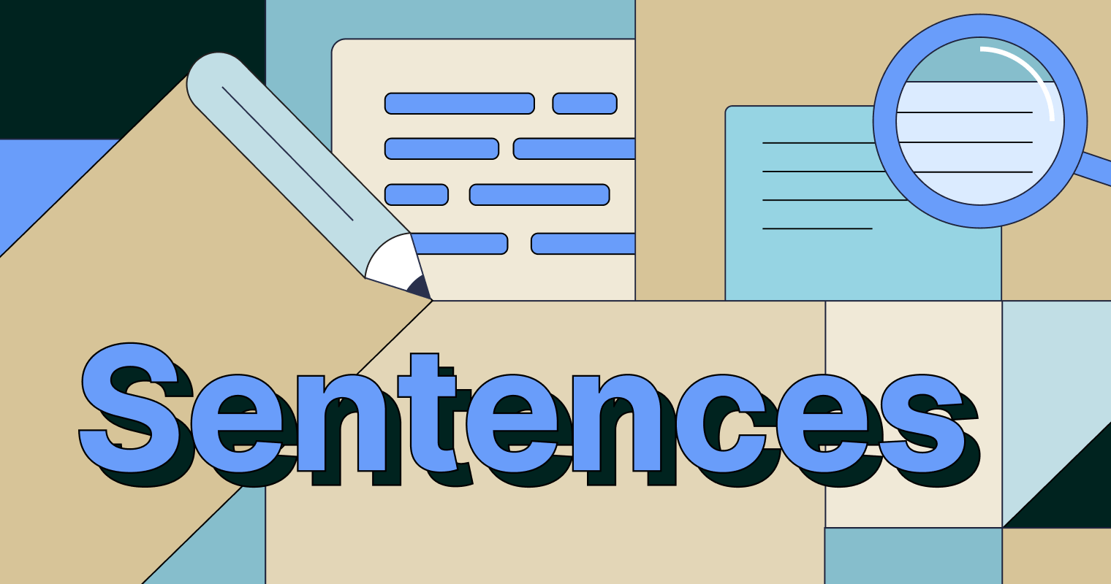

Sentences can follow each other in the following ways (among others):

**a)** argument + counter argument

**b)** opinion + supporting example(s)

**c)** opinion + supporting reason(s)

**d)** listing (reasons or examples)

**Q1. Match a sentence in column A with its follow on sentence in Column B**

**Ans.**   
**1.** Firstly, television news reports are often too short or superficial to explain the full context of a story.   
**Matched Sentence:** Secondly, television news editors tend to favor stories which offer sensational images that make “entertaining” viewing.

**2.** In my view, products such as cosmetics or soaps should not be tested on animals.  
**Matched Sentence:** Such items are not essential, and there is no need to make creatures suffer for the sake of making money.

**3.** I am convinced that governments’ economic policies do harm to the environment.  
**Matched Sentence:** For example, governments do very little to encourage people to use public transport instead of their cars, and are reluctant to pursue private companies that pollute the environment.

**4.** Some people believe that the only way to prevent crime is to enforce stricter punishments.   
**Matched Sentence:** However, statistics show that more severe punishments do nothing to reduce crime rates.

